Task 3: Develop and test a dual-LED blinking application using the ESP32-S3 with simultaneous 1000 ms ON and 1000 ms OFF intervals.
Components Required:
Hardware:
S.No | Component | Specification | Quantity
1 |  | ESP32-S3 DevKitC-1 | 1
  ESP32-S3
2 | LED | 5 mm | 2
3 |  |  | 2
  Resistor
  220 Ω or 330 Ω
4 | Breadboard |  | 1
  Standard
5 | Jumper Wires | Male-to-Female | 4-5
6 |  | USB 2.0/3.0 Data Cable | 1
  USB Type-C Data Cable
7 | Computer/Laptop | Windows 10/11 | 1
Software:
S.No | Software | Purpose
1 | Visual Studio Code  (VS Code) | Source code editor
2 |  | Project creation, build, upload, and debugging
  PlatformIO IDE Extension
3 | Arduino Framework | Provides libraries and APIs for ESP32-S3 programming
4 | ESP32 Platform Package (Espressif32) | Supports ESP32-S3 development in PlatformIO
5 | USB Serial Driver | Enables communication between the ESP32-S3 and the computer

Circuit Diagram:
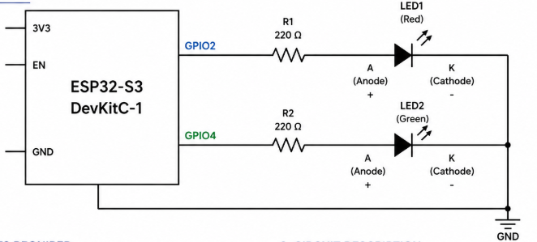
Flowchart:
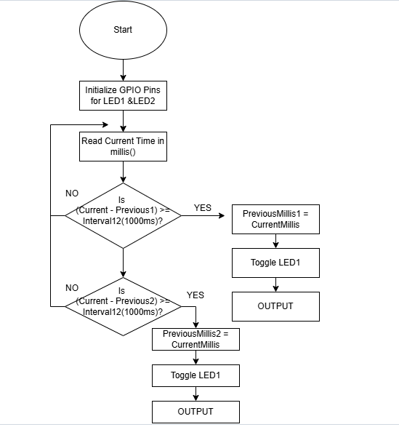
Code:

#includ <Arduino.h>
const int led1 = 2;
const int led2 = 4;

bool led1State = LOW;
bool led2State = LOW;

unsigned long previousMillis1 = 0;
unsigned long previousMillis2 = 0;

const unsigned long interval1 = 1000;
const unsigned long interval2 = 1000;

void setup() {
pinMode(led1, OUTPUT);
pinMode(led2, OUTPUT);
}

void loop() {

unsigned long currentMillis = millis();

if (currentMillis - previousMillis1 >= interval1) {
previousMillis1 = currentMillis;
led1State = !led1State;
digitalWrite(led1, led1State);
}

if (currentMillis - previousMillis2 >= interval2) {
previousMillis2 = currentMillis;
led2State = !led2State;
digitalWrite(led2, led2State);
}

}

Test Result:
S.No | Test Case | Expected Result | Actual Result | Status
1 | Power ON Test | ESP32-S3 powers ON successfully | Board powered ON successfully | Pass
2 | Hardware Connection Test | Circuit connections are correct | All connections verified | Pass
3 | Build Test | Code compiles without errors | Build completed successfully | Pass
4 | Upload Test | Firmware uploads successfully | Program uploaded successfully | Pass
5 | LED ON Test | Both LEDs turn ON simultaneously | Both LEDs turned ON together | Pass
6 | LED OFF Test | Both LEDs turn OFF simultaneously | Both LEDs turned OFF together | Pass
7 | Timing Test | LEDs remain ON for 1000 ms and OFF for 1000 ms | Timing verified as approximately 1000 ms | Pass
8 | Continuous Operation Test | LEDs blink continuously without interruption | LEDs blinked continuously as expected | Pass

Output:

